UNIT 2
CHAPTER 2.2

Introduction to PL/SQL Cursor
When you work with Oracle database, you work with a complete set of rows returned from an SELECT statement. However the application in some cases cannot work effectively with the entire result set, therefore, the database server needs to provide a mechanism for the application to work with one row or a subset of the result set at a time. As the result, Oracle created PL/SQL cursor to provide these extensions.
A PL/SQL cursor is a pointer that points to the result set of an SQL query against database tables.
Working with PL/SQL Cursor
The following picture describes steps that you need to follow when you work with a PL/SQL cursor:
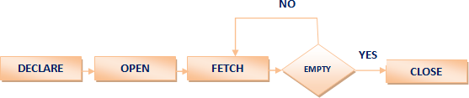
Fig 1: PL/SQL Cursor
Oracle has dedicated memory locations for executing SQL statements and then it holds that processed information, for example, the total number of rows updated.
A cursor in PL/SQL gives a name and acts as a pointer to the area of work called a context area and then uses its information. It keeps the number of rows processed by the SQL statement. These rows are called as an active set. The size of the active set is equal to the count of the rows that meet the condition.

There are two types of cursors which are listed below:
1. Implicit Cursor
2. Explicit cursor
Implicit cursors are automatically created by Oracle whenever an SQL statement is executed, when there is no explicit cursor for the statement. Programmers cannot control the implicit cursors and the information in it.
Whenever a DML statement (INSERT, UPDATE and DELETE) is issued, an implicit cursor is associated with this statement. For INSERT operations, the cursor holds the data that needs to be inserted. For UPDATE and DELETE operations, the cursor identifies the rows that would be affected.
In PL/SQL, you can refer to the most recent implicit cursor as the SQL cursor, which always has attributes such as %FOUND, %ISOPEN, %NOTFOUND, and %ROWCOUNT. The SQL cursor has additional attributes, %BULK_ROWCOUNT and %BULK_EXCEPTIONS, designed for use with the FORALL statement. The following table provides the description of the most used attributes −
1. %FOUND
Returns TRUE if an INSERT, UPDATE, or DELETE statement affected one or more rows or a SELECT INTO statement returned one or more rows. Otherwise, it returns FALSE.
2. %NOTFOUND
The logical opposite of %FOUND. It returns TRUE if an INSERT, UPDATE, or DELETE statement affected no rows, or a SELECT INTO statement returned no rows. Otherwise, it returns FALSE.
3. %ISOPEN
Always returns FALSE for implicit cursors, because Oracle closes the SQL cursor automatically after executing its associated SQL statement.
4. %ROWCOUNT
Returns the number of rows affected by an INSERT, UPDATE, or DELETE statement, or returned by a SELECT INTO statement.
Any SQL cursor attribute will be accessed as sql%attribute_name
Example
We will be using the CUSTOMERS table
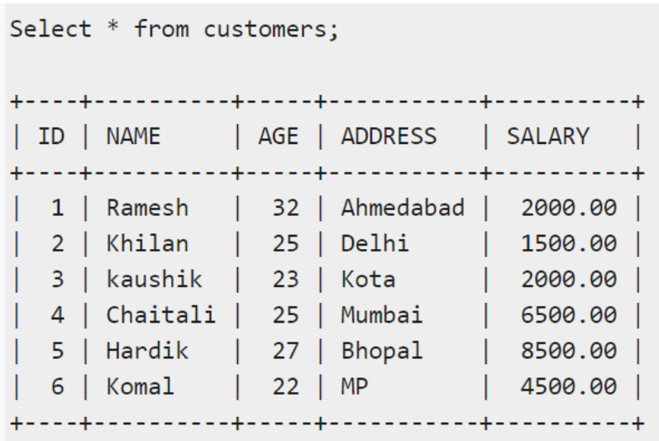
The following program will update the table and increase the salary of each customer by 500 and use the SQL%ROWCOUNT attribute to determine the number of rows affected –
DECLARE
total_rows number(2);
BEGIN
UPDATE customers
SET salary = salary + 500;
IF sql%notfound THEN
dbms_output.put_line('no customers selected');
ELSIF sql%found THEN
total_rows := sql%rowcount;
dbms_output.put_line( total_rows || ' customers selected ');
END IF;
END;
/
When the above code is executed at the SQL prompt, it produces the following result −
6 customers selected
PL/SQL procedure successfully completed.
If you check the records in customers table, you will find that the rows have been updated −
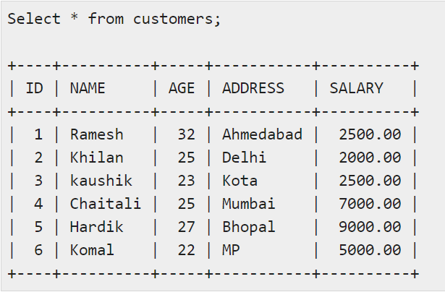
Explicit Cursors
Explicit cursors are programmer-defined cursors for gaining more control over the context area. An explicit cursor should be defined in the declaration section of the PL/SQL Block. It is created on a SELECT Statement which returns more than one row.
The syntax for creating an explicit cursor is –
CURSOR cursor_name IS select_statement;
Working with an explicit cursor includes the following steps −
- Declaring the cursor for initializing the memory
- Opening the cursor for allocating the memory
- Fetching the cursor for retrieving the data
- Closing the cursor to release the allocated memory
Declaring the Cursor
Declaring the cursor defines the cursor with a name and the associated SELECT statement. For example −
CURSOR c_customers IS
SELECT id, name, address FROM customers;
Opening the Cursor
Opening the cursor allocates the memory for the cursor and makes it ready for fetching the rows returned by the SQL statement into it. For example, we will open the above defined cursor as follows −
OPEN c_customers;
Fetching the Cursor
Fetching the cursor involves accessing one row at a time. For example, we will fetch rows from the above-opened cursor as follows −
FETCH c_customers INTO c_id, c_name, c_addr;
Closing the Cursor
Closing the cursor means releasing the allocated memory. For example, we will close the above-opened cursor as follows −
CLOSE c_customers;
Example
Following is a complete example to illustrate the concepts of explicit cursors &minua;
DECLARE
c_id customers.id%type;
c_name customer.name%type;
c_addr customers.address%type;
CURSOR c_customers is
SELECT id, name, address FROM customers;
BEGIN
OPEN c_customers;
LOOP
FETCH c_customers into c_id, c_name, c_addr;
EXIT WHEN c_customers%notfound;
dbms_output.put_line(c_id || ' ' || c_name || ' ' || c_addr);
END LOOP;
CLOSE c_customers;
END;
/
When the above code is executed at the SQL prompt, it produces the following result −
1 Ramesh Ahmedabad
2 Khilan Delhi
3 kaushik Kota
4 Chaitali Mumbai
5 Hardik Bhopal
6 Komal MP
PL/SQL procedure successfully completed.

Other References
- PL/SQL - Cursors - Tutorialspoint
- PL/SQL Cursor - javatpoint
- PL/SQL Cursor (plsqltutorial.com)
Suggested Book References
- C.J.Date, “An Introduction to DatabaseSystems”, Addison Wesley.
- Thomas M. Connolly, Carolyn & E.Begg,“Database Systems: A Practical Approach to Design, Implementationand Management”, 5/E, University of Paisley, Addison-Wesley.
- Rob,”Database Principal Fundamental Design, Cengage Learning.

